**ASSIGNMENT 3: Registration Page**

HALAK JIGNESHBHAI VYAS

012629812

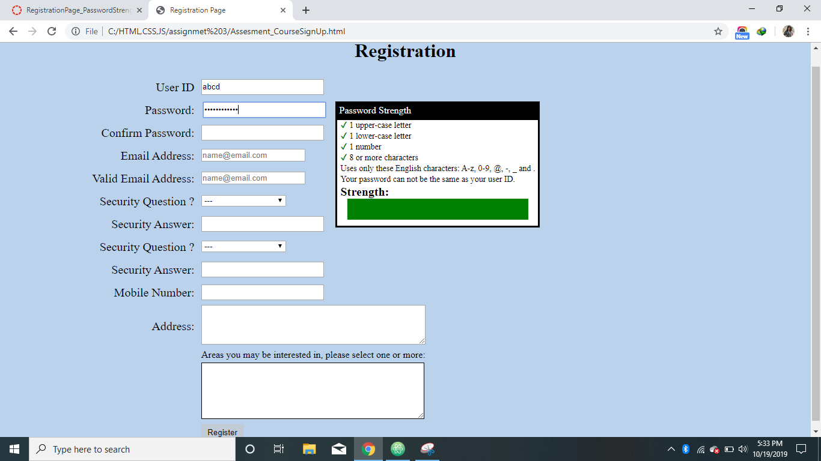

Password Strength

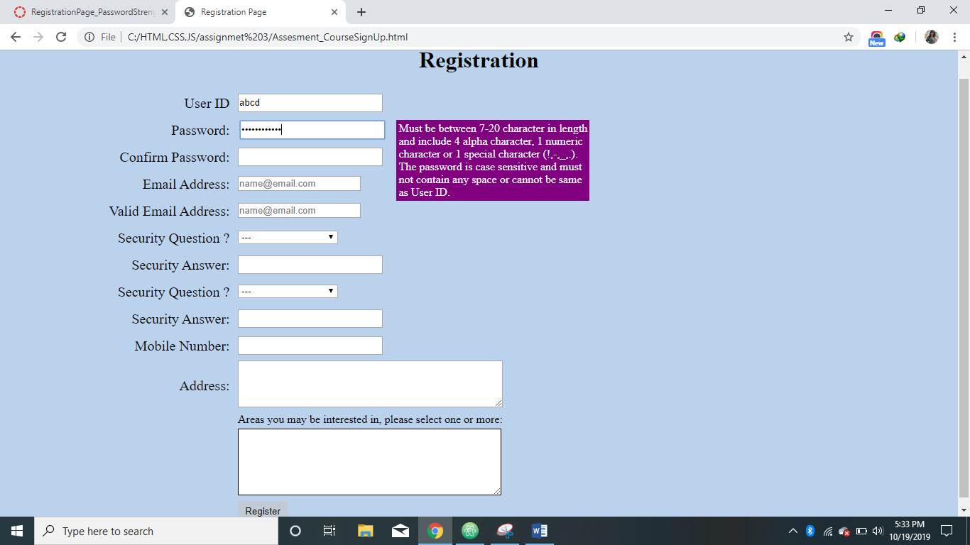

Password Pattern

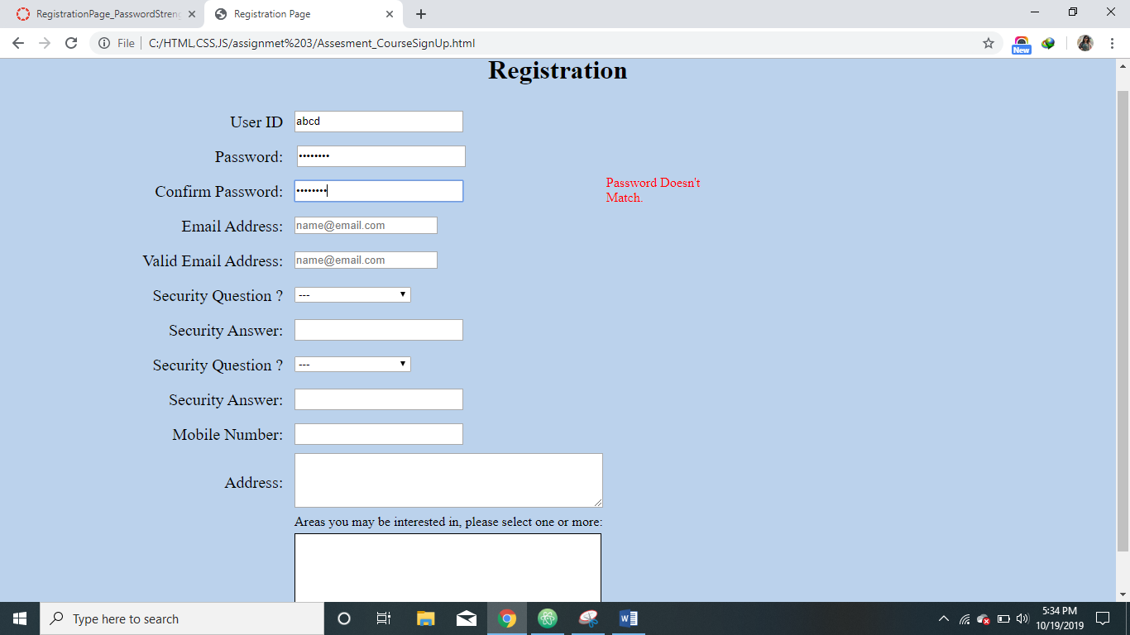

If Password Not Matched

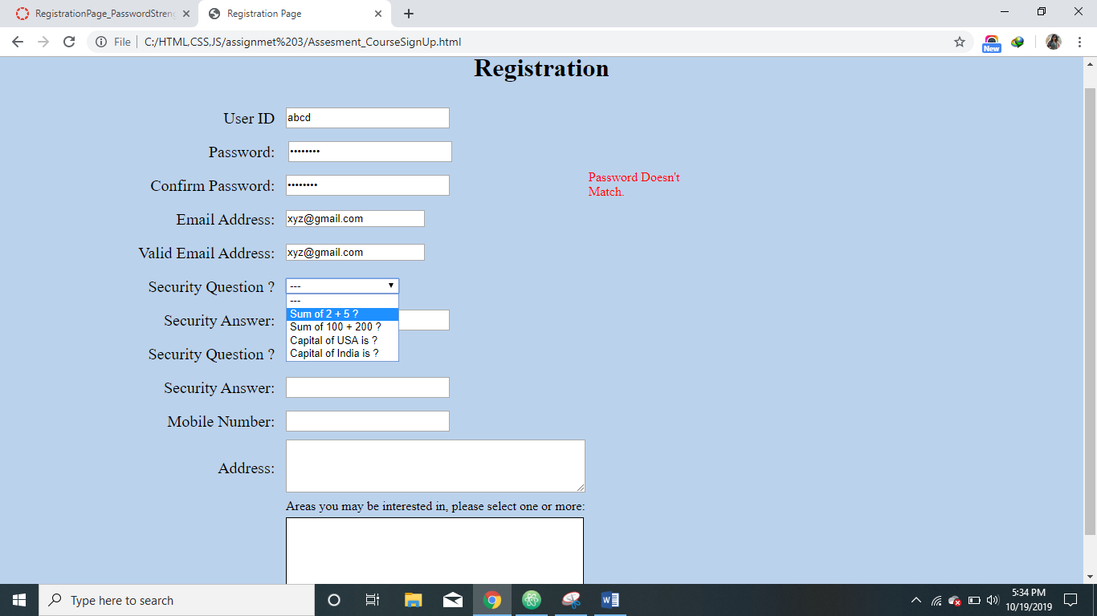

Security Questions

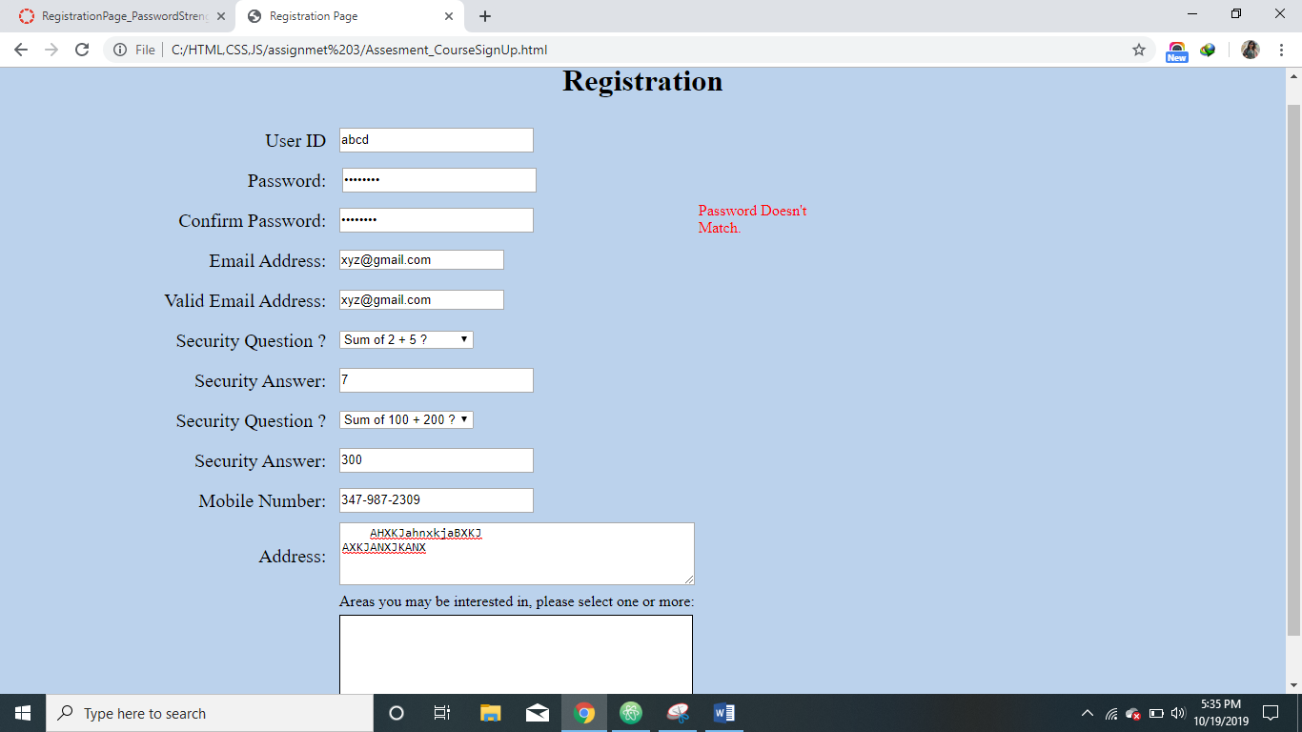

Mobile Number/ Address Box

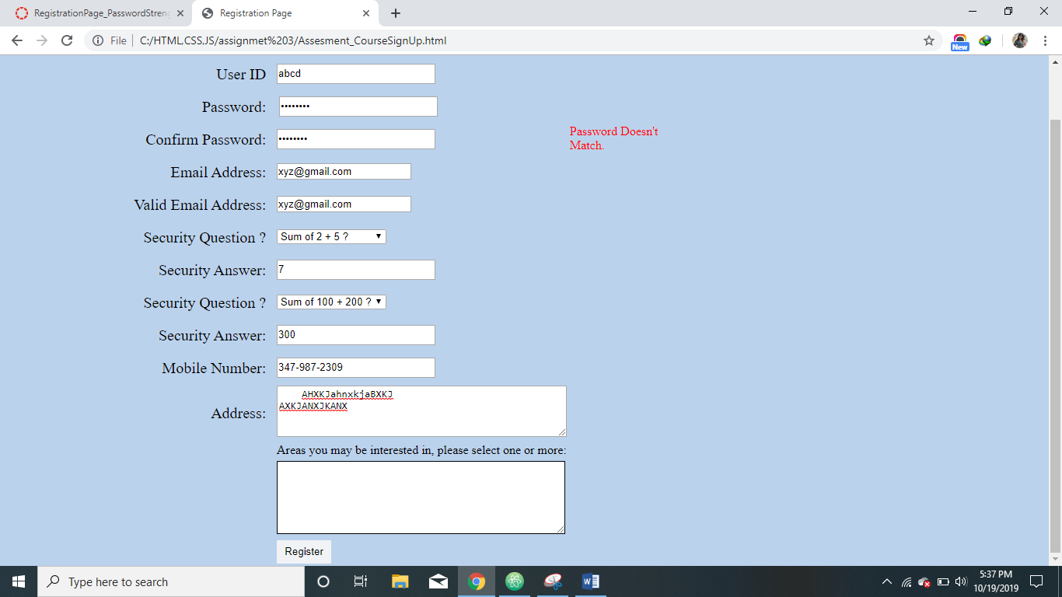

Whole Page



Storing User Information